**Assignment: Retrieve Data from Multiple Tables**

Brandon Trinkle

Arizona State University

IFT 300

Professor Ashish Gulati

11/4/2024

**Assignment: Retrieve Data from Multiple Tables**

1. Write a SELECT statement that returns all columns from the Vendors table inner-joined with the Invoices table.

/*

** Author: Brandon Trinkle

** Course: IFT/300

** SQL Server Version: Microsoft SQL Server 2012 (SP1)

** OS : Windows

** History

** Date Created Comments

** 10/28/2024 Question 1

*/

SELECT *

FROM Vendors

INNER JOIN Invoices ON Vendors.VendorID = Invoices.VendorID;

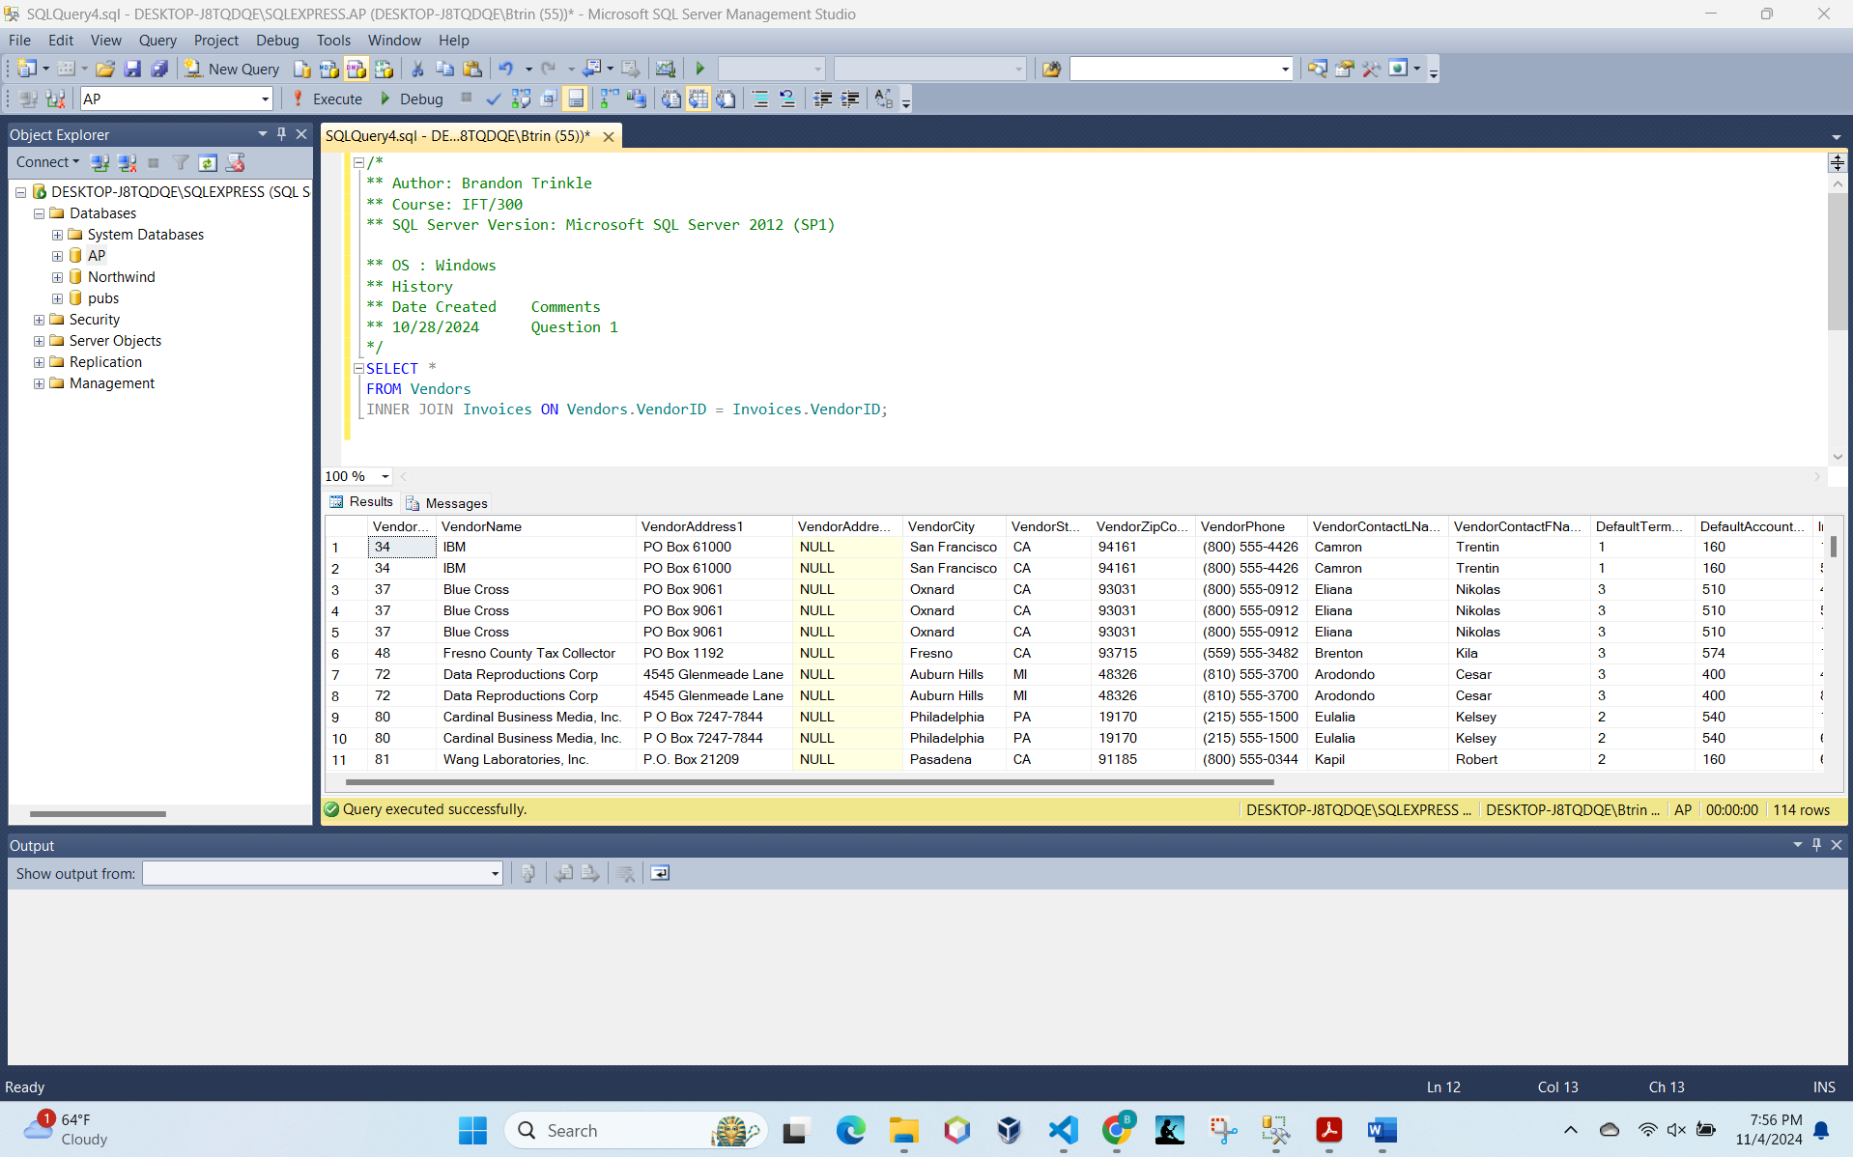

2. Write a SELECT statement that returns four columns:

VendorName From the Vendors table

InvoiceNumber From the Invoices table

InvoiceDate From the Invoices table

Balance InvoiceTotal minus the sum of PaymentTotal and CreditTotal

The result set should have one row for each invoice with a non-zero balance. Sort the result set by VendorName in ascending order.

/*

** Author: Brandon Trinkle

** Course: IFT/300

** SQL Server Version: Microsoft SQL Server 2012 (SP1)

** OS : Windows

** History

** Date Created Comments

** 10/28/2024 Question 1

*/

SELECT

Vendors.VendorName,

Invoices.InvoiceNumber,

Invoices.InvoiceDate,

(Invoices.InvoiceTotal - (Invoices.PaymentTotal + Invoices.CreditTotal)) AS Balance

FROM Vendors

INNER JOIN Invoices ON Vendors.VendorID = Invoices.VendorID

WHERE (Invoices.InvoiceTotal - (Invoices.PaymentTotal + Invoices.CreditTotal)) <> 0

ORDER BY Vendors.VendorName ASC;

3. Write a SELECT statement that returns three columns:

VendorName From the Vendors table

DefaultAccountNo From the Vendors table

AccountDescription From the GLAccounts table

The result set should have one row for each vendor, with the account number and account description for that vendor’s default account number.

/*

** Author: Brandon Trinkle

** Course: IFT/300

** SQL Server Version: Microsoft SQL Server 2012 (SP1)

** OS : Windows

** History

** Date Created Comments

** 10/28/2024 Question 1

*/

SELECT

Vendors.VendorName,

Vendors.DefaultAccountNo,

GLAccounts.AccountDescription

FROM Vendors

INNER JOIN GLAccounts ON Vendors.DefaultAccountNo = GLAccounts.AccountNo;

